9.Write a Pandas program to create a Pivot table and find the total sale amount region wise, manager wise, sales man wise.
PROGRAM:
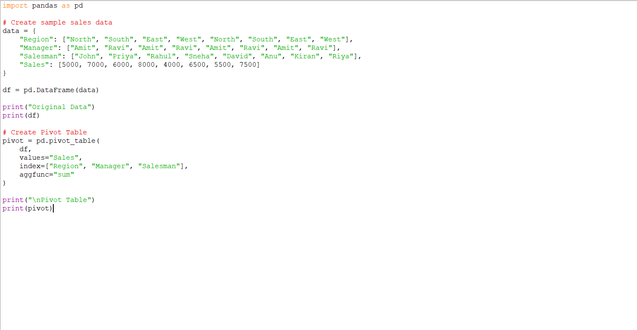
OUTPUT:
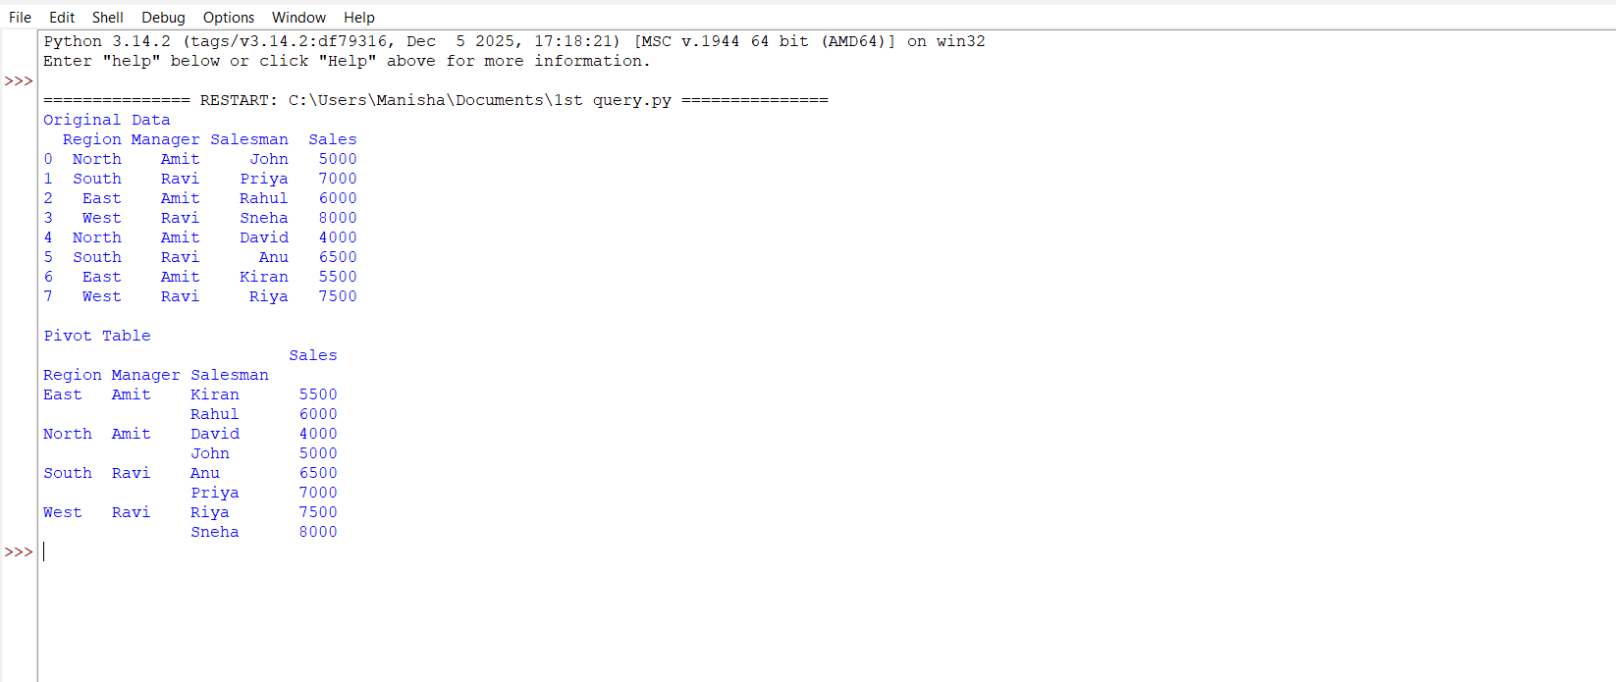

10. Create a DataFrame of ten rows and four columns with random values. Highlight negative numbers in red and positive numbers in black.
Aim
The aim of this program is to create a Pandas DataFrame with 10 rows and 4 columns containing random positive and negative numbers, and use Pandas Styling to display negative values in red and positive values in black, making the data easier to analyze visually.
PROGRAM:
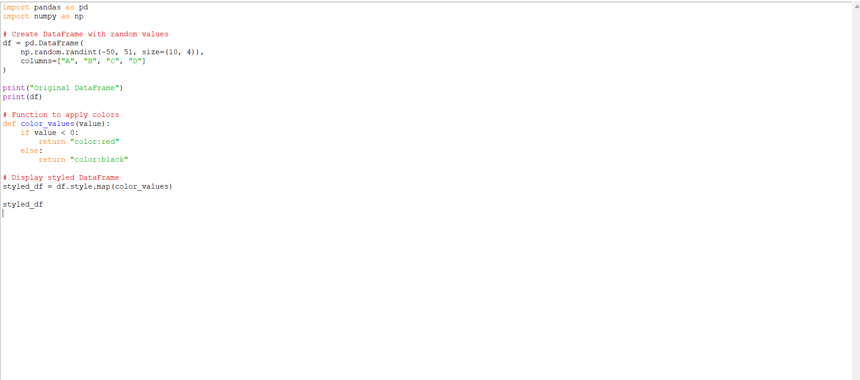

OUTPUT:
